## horizontal line



AQUASTIC FIRE EXTINGUISHING PREDICTION

Members:

ATHIRA B HARI

ASWANI TP

MRUDUL S MOHAN

ANAGHA B R

**Acoustic Fire Extinguishing Prediction**

# 1.INTRODUCTION

# 1.1 OVERVIEW

Fire is one of the biggest hazards posed to humans due to high industrialization. This hazard can be controlled with the help of Fire Brigades and on smaller levels can be controlled with the help of fire extinguishers. The fire extinguishers are made up of chemicals and leave behind foam or chemicals after putting out the fire. These chemicals are harmful to humans and can also damage the equipment used in office creating higher loss.

The acoustic fire extinguisher used sound waves to put out fire. The fire can be curbed with the help of sound waves at certain frequencies. But there are limitations as to how big fire can be taken down with the acoustic fire extinguisher. Experiments were conducted where the researchers conducted experiment to put of fire. There were many changes made in each experiment like the frequency of sound waves, the distance of fire extinguisher, type of fuel, etc. The model we have built based on data can predict whether fire can be taken down with the acoustic fire extinguisher or no.

**1.2 PURPOSE**

The purpose of Acoustic Fire Extinguishing Prediction is to leverage advanced acoustic sensing technology to enhance fire prevention and firefighting efforts. By analyzing the distinct acoustic signatures produced by fires, this innovative approach aims to provide early detection of fires, predict their behavior, and improve the efficiency of fire suppression. Acoustic sensors can detect subtle sounds associated with fires, enabling rapid response and the automatic activation of firefighting systems when a fire is detected

**2.LITERATURE SURVEY**

Many studies have explored the use of acoustic sensors for fire detection. These sensors can pick up distinct acoustic signals associated with different types of fires, such as crackling, popping, or roaring sounds.Research has shown that acoustic detection can provide an early warning system for fires, allowing for faster response times.

# 2.1 Existing problem

The existing problems in Acoustic Fire Extinguishing Prediction (AFEP) include false alarms due to non-fire sounds, variability in acoustic signatures for different fires, sensitivity to environmental conditions, integration complexity with existing systems, high initial costs and maintenance, scalability challenges, privacy concerns, regulatory compliance issues, and the need for rigorous testing and validation under various conditions. These challenges must be overcome for effective AFEP implementation and improved fire safety.

**2.2 Proposed solution**

Proposed solutions for Acoustic Fire Extinguishing Prediction (AFEP) challenges include advanced machine learning algorithms for better sound analysis, improved sensor technology for increased accuracy and range, environmental modeling for robust predictions, seamless integration with existing fire systems through standardized interfaces, cost-effective hardware and maintenance solutions, privacy safeguards like data encryption and anonymization, adherence to evolving fire safety regulations, and rigorous testing under diverse conditions to enhance reliability and performance. These solutions aim to address AFEP's existing problems and enhance its effectiveness in fire safety applications.

# 3.THEORITICAL ANALYSIS

Acoustic Signatures: AFEP relies on the premise that fires generate distinct acoustic signatures, which can vary depending on the type of fire, materials involved, and environmental conditions. Theoretical analysis involves studying the physics of sound propagation in fire environments and understanding how fires produce unique acoustic emissions.

# 3.1Block diagram

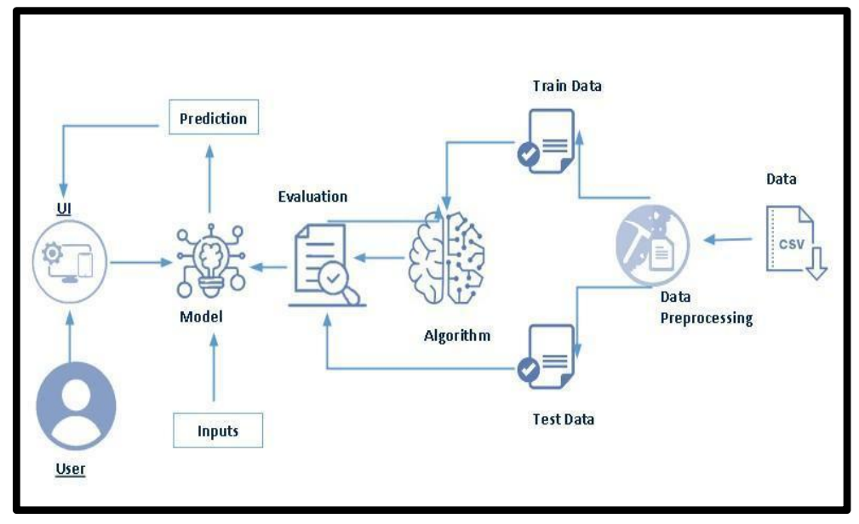

# 3.2 Hardware / Software designing

**Hardware Requirements:**

**1. Computer/Server:**

You will need a computer or server with sufficient processing power to train and run ML models.

**2. Memory (RAM):**

The amount of RAM you need depends on the size of your dataset and the

complexity of your models.

**3. Storage:**

You will need enough storage space to store your datasets, model weights, and any

other project-related files. SSDs (Solid State Drives) are recommended for faster

data access.

.

**4. Internet Connection:**

A reliable internet connection is essential for downloading libraries, updates, and

accessing cloud-based services if needed.

**Software Requirements:**

**1. Operating System:**

Python is platform-independent, so you can use Windows, macOS, or Linux. Linux

is often preferred for server-based ML projects due to its stability and ease of use.

**2. Python:**

Python is the primary programming language for ML and data science. You&#39;ll need

Python installed on your system. Python 3 is the recommended version.

**3. Development Environment:**

You can use a text editor like Visual Studio Code, PyCharm, or Jupyter Notebook as

your development environment.

**4. Machine Learning Libraries:**

Install ML libraries like scikit-learn, TensorFlow, Keras, PyTorch, and pandas. These

libraries provide tools for data preprocessing, model training, and evaluation.

# 4.EXPERIMENTAL INVESTIGATIONS

**Social Impact:**

Whenever there is a fire, the people around and the environment does not get affected due to acoustic fire extinguisher. People can use this model to adapt to a safer and cleaner way to put out fire.

**Business Impact:**

Will positively impact the companies manufacturing the acoustic fire extinguishers. This will also help larger corporations and housing complexes to save money as the acoustic fire extinguisher does not need refill or does not expire.

# 

# 5.FLOWCHART